Middleton on Sea Association Newsletter November 2017

Chairman’s Column

Scheme of Delegation
In our last Newsletter, I drew your attention to Arun DC’s “new” planning procedure which is described on page 2 of the Parish Council’s Spring Magazine. Under that procedure it would have been necessary to persuade the Parish Council to object to any planning application which we did not approve, otherwise there was a danger that it would be decided by a Planning Officer exercising delegated powers.

Now I have to report that Arun DC changed their policy again in June 2016. This only came to light after we had discovered that the Planning Officer had granted permission to the owner of a property on our estate, despite the fact that both we and the Parish Council had objected to the application. We had assumed that the application would go before the Arun DC’s Development Control Committee for a decision because the Parish Council had supported our objections to it.

After having been told about the “new revised procedure”, our Planning Advisory Sub-Committee found that it was inconsistent with the advice given about objections to planning applications on Arun DC’s website. They then sent out a blizzard of e-mails and letters on the subject to the Planning Department, several District Councillors, our PC and numerous other Parish Councils with a view to persuading Arun to change their policy yet again. The matter is due to be discussed by the Arun Development Control Committee quite shortly. I have been told that there is a possibility that planning applications will once again be referred to that Committee but only if the local ‘ward member’ (i.e. the District Councillor who represents our area) supports the objection. If this compromise solution is adopted, I believe that it will in no small part be due to the intense lobbying of our Advisory Sub-Committee.
Natural England – Coastal Path
I have spent much time in recent weeks reviewing Natural England’s proposals to designate part of
our estate as the trail for a new coastal path in our area together with their maps and the relevant legislation. If the proposals are implemented, the path will run through Old Point and our greensward.

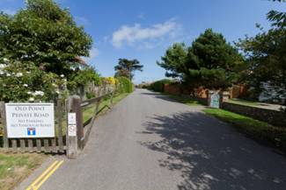

In the light of sundry observations made by some residents, I propose to object to the proposals unless I am advised not to do so by the Country Land and Business Association whose opinion on the matter I am seeking.

Pond and Green
The working party continues to meet on site every 4 weeks to carry out maintenance work. On 21stOctober we intend to construct a 6 foot bay made up of posts and chicken wire which will be sited to provide a leaf disposal and potential compost area.

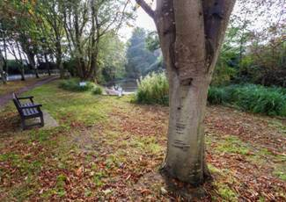

The bay will be below road level and will be fronted by nettles and cow parsley in the summer. It will also be a haven for hibernating hedgehogs. Hopefully, the existence of the bay will reduce the quantity of leaves which will have to be taken away after our leaf-sweeping event on Saturday 2nd December. The other event which I must tell you about is our AGM which will take place on Wednesday 6th December in the rear Jubilee Hall at 7.30pm. We anticipate that by the end of November we will have planted 2,500 bulbs to flower next spring, including the crocus bulbs kindly donated by the Rotary Club for which we are most grateful.

Bed and Breakfast businesses
We have been informed that the residents of three properties on our estate are now letting rooms in their houses on a bed and breakfast basis, or have recently done so. I gather that these services have been advertised on the Airbnb website. Your Committee does not approve of these activities – see our Advisory Sub-Committee’s report on this subject set out on page 4.

Parking
May I once again remind residents that parking on our estate roads is prohibited.

Thanks
May I thank the rest of the Management Committee and the Advisory Planning Sub-Committee for their support and encouragement during the past six months.

Michael Leete

Sandcastle Competition

Although not quite so many entrants this year the standard was still very high making it difficult to determine the winners. Amongst the sculptures was a superb stadium, a castle and a dolphin. Great enthusiasm was shown by all the participants and the event was greatly enjoyed by all those who took part. The eventual winners for the ‘Children only’ event were Georgie Everett, Alex and Mia Fenn-Smith with a very splendid Ice Cream Cornet decorated with stones and shells from the beach.

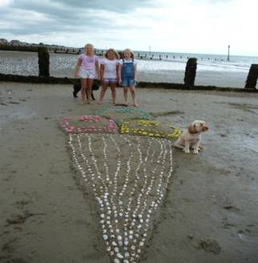

The ‘Adult only’ winner was Tim Saltwell with a painstakingly accurate sculpture of a very handsome crocodile.



The Family winners were Guy and Emma Everett with their sons Ben and Tom who sculpted a piece of Middleton history in the shape of The Sunken Church. Sadly, when the tide came in this copy suffered the same fate as the original.



It was so nice to see a number of residents who just came along to enjoy the morning and admire the splendid creations.

This event has firmly become a “tradition” for MOSA, and long may it continue!

Margaret Martin

Boules Evening

This event has also become a firm favourite on the MOSA calendar and this year (8th) was no exception. It was a beautiful evening with a record number of people attending and playing Boules, some new to the game and others who had clearly played many times before! It was great to welcome some of our new residents willing to join in the games and who clearly enjoyed the occasion. When Middleton people get together they know how to enjoy themselves and not take the competition too seriously!
Many people brought picnic baskets filled with their favourite foods and coolers filled with their favourite tipples!

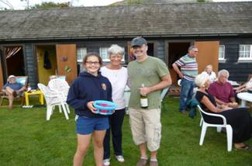
Thanks must go to John Bradshaw and Roger Hills for providing hot dogs and to Chris Martin for organizing the Boules.

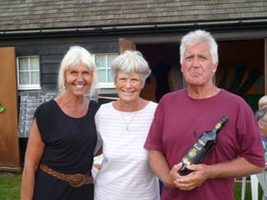

The eventual winners were 1st William and Sonja Fox, 2nd Izzie and John Bevan, 3rd Rosie Tuson and Margaret Martin.

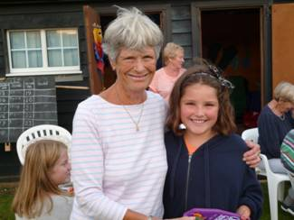

Margaret Martin

Welcome new residents

The MOSA Management Committee would like to welcome the following residents to our estate:-

Derek & Beverly Bennett West Close
Will & Sonja Fox East Close
Martin & Christine Haywood South Walk
Dermott & Sarah Rice East Close
John & Carol Stride East Close
Martin & Brenda Swift South Walk
Grant & Kirsty Cane 10 West Close
Mr Filippo & Ms O’Neill 120 Middleton Road
Mr & Mrs Byrne 106 Middleton Road

Private Houses – not Business Properties

Earlier this year members of the Management Committee of this Association were asked to consider the practice of residents working from home and/or using their home for business purposes. Although there are clear provisions in the Schedule of Restrictive Covenants attached to the Deeds of properties on private roads on the estate regarding ‘business use’, we accept that times have changed.
With the advent of the internet and e-mail, video conferencing etc., some professions can and do operate from home without causing any disturbance or nuisance to neighbours, or causing additional traffic or parking problems on our roads. There are also properties on private roads that are let on an annual or shorter term basis. However, there are no obvious signs or outward indication that such properties are other than private dwellings.
The history, design and construction of houses on the private roads were exclusively for private dwellings. No doubt all, but if not, the vast majority of current residents, purchased their property in the belief that they were to live on a private residential estate.
However, concerns have recently been raised regarding the practice of dwellings on private roads on the estate offering temporary accommodations by way of bed and breakfast or other boarding facilities. The prohibition of this practice was expressly provided for in the Restrictive Covenants which required that properties “must not be used or occupied in more than one tenement”, or “not to be used other than as a private residence”.
Any property providing temporary additional accommodation services usually brings more traffic, increased parking and the potential for other disturbance and nuisance, together with unfair liability for road charges. It also increases the real probability that a precedent will be set for expansion of such businesses to include Hotels or Hostels, with the obvious risk of increased consequences for other residents. Your Management Committee assume that most residents would not welcome the prospect of a Hotel, Hostel or similar establishment as a neighbouring property. There are also practical considerations for such business operations. These include implications regarding homeowner’s insurance, Health and Safety considerations, Fire Safety requirements and, if appropriate, compliance with any mortgage conditions. Most importantly, providing accommodation services could constitute a change of use of the property, requiring planning permission.
The Management Committee of this Association seeks to reassure residents that it is committed to preserving the private residential estate and will support the principle that private dwellings on the estate should not be used in more than one tenement. The use of domestic dwellings for commercial purposes such as Hotels, Boarding Houses and Bed and Breakfast is therefore not encouraged and will be notified to the Planning Authorities.

Winter Gardens

At this time of year we are busy preparing our gardens for the colder weather we have come to expect over the next few months. We need to have a look at our larger trees and remove any branches which appear sick or damaged. These are the ones which will fall in a storm. Look out for honey fungus on decaying stumps as this can spread to vulnerable plants. It can be treated with reasonable success with a fungicide if so wished. Clipped hedges should have had their last haircut of the season and there a couple of weeks left to gently prune those roses if you have forgotten.
Remember to protect fragile tubers, such as dahlias, (if you aren’t lifting them) with a good thick mulch of compost or leaf mould. Delicate shrubs such as tree ferns will benefit from a light coat of white fleece to protect them from the hard frost.
Finally, do make sure you rake the leaves from your lawn so that grass is not smothered. Bag and tie them in bin liners, put a few holes in them, and hide them away until next winter, you will then have wonderful leaf mould to protect your more delicate plants!

